Screenshot of code testing
Michael McClay
B01886622

Task 1:
Sub program - Security event counter:
This screenshot shows all 10 password attempts with different data types being tested. This also shows option 4 exit working as well.
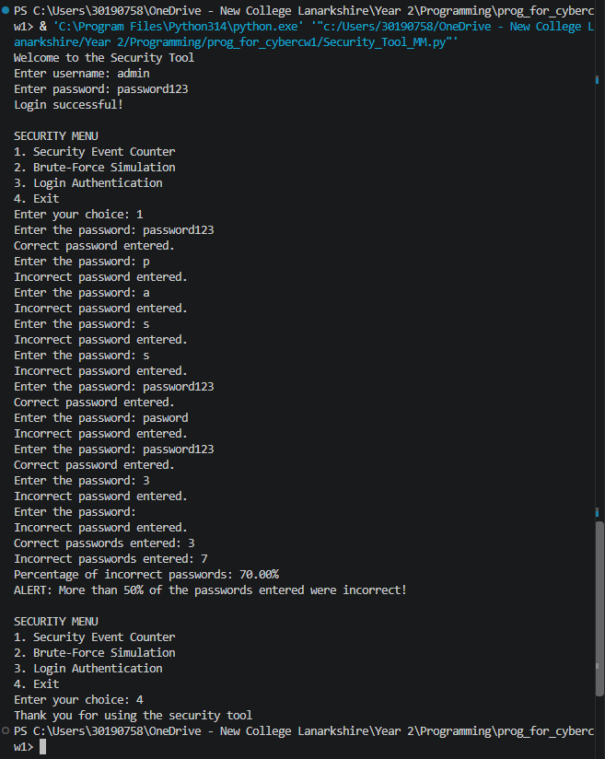
Sub program - Brute-force simulation:
Screenshot below shows code working as intended
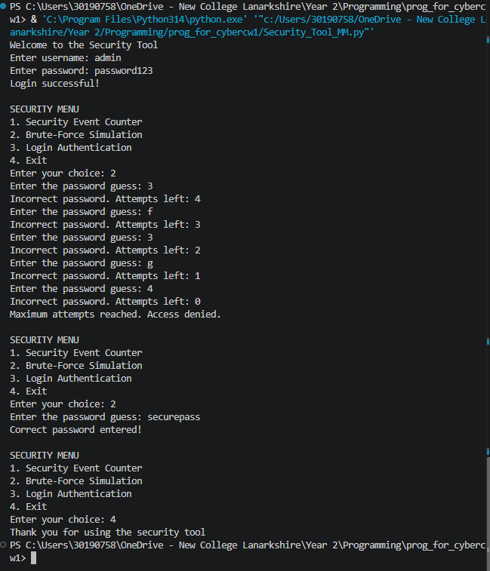

Sub program - Login authentication:
Screenshot shows code working as intended


